Practical 1 Basic introduction to MS Access

In this practical, you will be introduced to simple concepts of the database using MS Access.

You will find a sample of the Access database in Blackboard. Open the access database.

Viewing of tables

- Open the Ms Access file: TUTEg.mdb. Enable Editing. From the left pane of the window you should see a list of Access Objects, such as Tables, Queries and Reports.
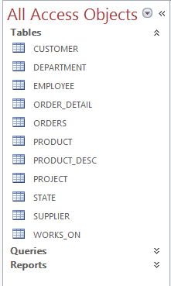

Viewing of table data

2. Double click on the table you want to view, such as CUSTOMER.

3. You should see the data as follows:

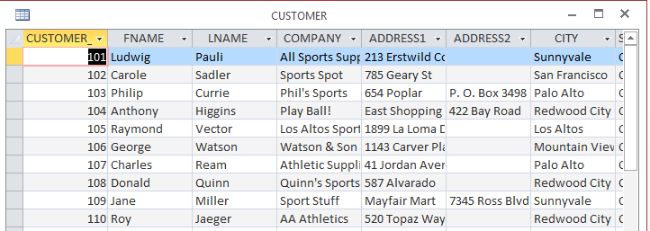

Viewing of table structure

4. Click on View and choose Design View.

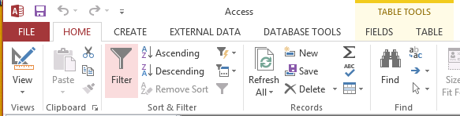

5. You should see the table structure as follows:

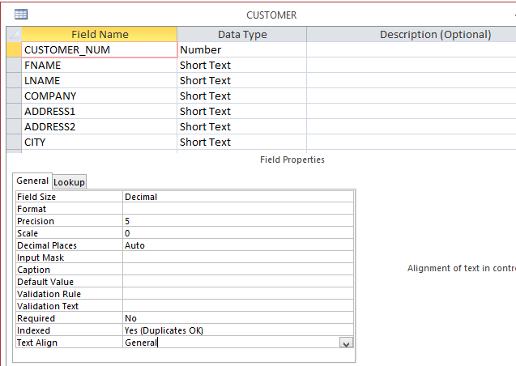
6. Explore the various data types available for Access. E.g. Text, Number, date/time.

Viewing of table relationships (connections between the tables)

7. Still in the Design tab and choose Relationships.

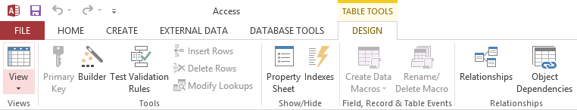

8. You should be able to see all the links between the tables as follows:

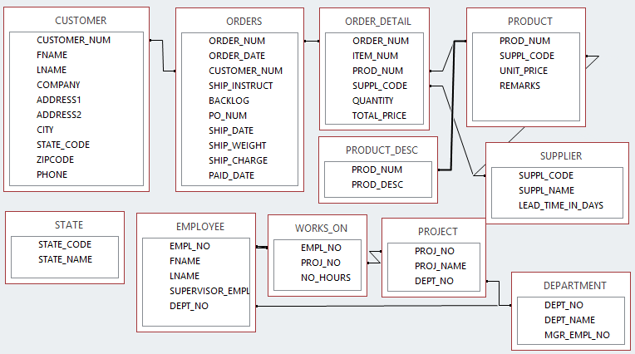

Creating a relation between tables

9. There is a link missing in the tables. Can you identify it?
Customer.State_code <=>State.state_code

10. Click on State_code in Customer table and drag over to the state_code in the State table. You should get a pop-up dialog box (see below). Click the create button. The relationship is defined.

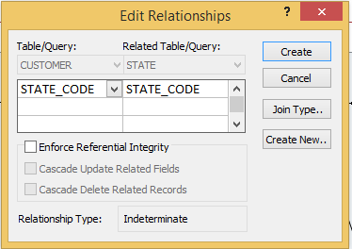

11. The relationship is created as show below:
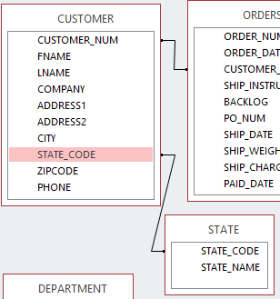

Querying the database using Design view
A query is a request for data or information from a database table or combination of tables. In Microsoft Access, you can create a query in 3 ways: Query Wizard, Query Design View, and SQL View.

First, let’s use query design view to generate a list of customers with only the customer_num, company name and the state_code shown in the list.

12. Click on the Create tab follow by the Query Design.

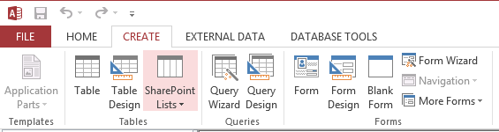

13. You should get the screen as below. Select customer and click on Add. Then close the Show Table dialog.

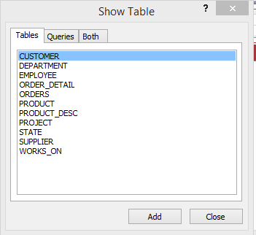

14. In the query window, double click on CUSTOMER_NUM, COMPANY and STATE_CODE.
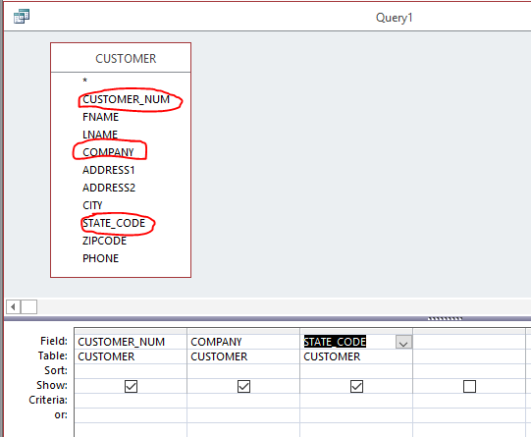

15. Click the View dropdown list to switch among datasheet view, design view and SQL view. What are the differences and connections among the 3 views?

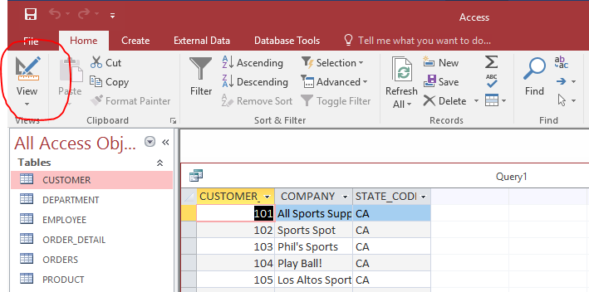

16. Now we want to add in a filter to only see the above customer information for customers in the state ‘CA’.
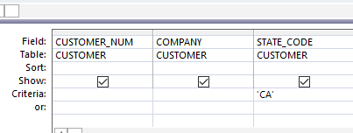

17. Click on the Run button.

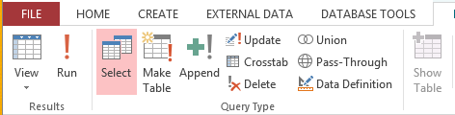

18. You should get the result as follows:
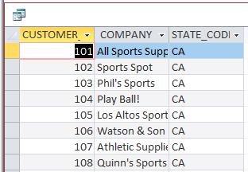

19. Close the query window by clicking the x button at the right top corner of the Query design window. When prompt for saving the query, enter the query name as “CA customers”, then click OK.
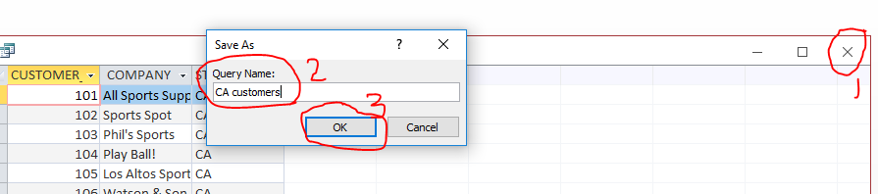

20. Now you should see your newly created query in the Objects browser.
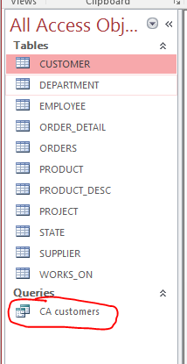

21. Create and run the following queries using Design view or other query features in Microsoft Access. Save each query you created.

a. Select order number, order date and customer number from Orders table.

b. Select product number, unit price from Product table where supplier code
is ‘ANZ’.

c. Select customer number, first name, last name and phone number from Customer table where state code = ‘AZ’.

d. Select order number, order date, item number, product number, quantity
and total price from both Orders and Order_Detail tables.

e. Select supplier code, supplier name and product number from both
Supplier and Product tables.

Submit the final Access file to blackboard.

**************************** THE END ***********************************

